Elizabeth Evans

MSIS 510, Autumn 2020 Purple

Assignment 2

1. 150, 329, 300, 2027, 144, 275, 205

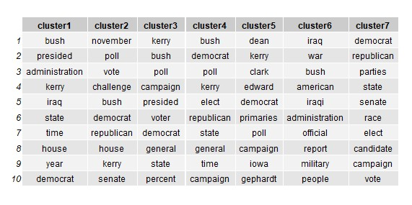

1. Cluster 6
2. Cluster 5